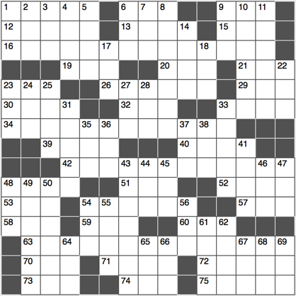 **ACROSS**

1. See 16-Across

4. Mimic

9. Fitting

12. Start of el año

13. Soccer star Mia

15. Confucian doctrine

16. Event occurring in 75-Across, or justification for 34-, 42- and 63-Across

19. “We’re ____ to see the wizard…”

20. First-aid ace

21. Cry noisily

23. Physician’s group, abbr.

26. Births after Virgos

29. Airport approximation

30.

32. ____-mo (replay speed)

33. Normandy invasion time

34. 1775 event that occurred on the 18th of 75-Across, as recorded by Henry Wadsworth Longfellow

39. College in New Rochelle, NY

40. Depend (on)

42. See 34-Across

48. Kegger venue

51. Low-lying island

52. Island where Napoleon was exiled

53. Place to go, for short?

54. Concurs

57. Avocado center

58. Verb ending?

59. Doll’s partner

60. Assents at sea

63. T.S. Eliot’s description of 75-Across, with “the”

70. Donkey

71. Capital of Peru

72. “It’s a Wonderful Life” director Frank

73. Meadow

74. Alternative to “gov” or “edu”

75. It’s showers are said to be responsible for May flowers

**DOWN**

1. Chess pieces
2. ____ roll (winning)
3. Court divider
4. Harry, Ron and Hermione, for example
5. Horse’s foot
6. “I get it!”
7. Buddy
8. A kind of penguin or ruler
9. Verizon competitor, abbr.
10. Broke down, to a grammarian
11. Prius maker

14. Midtown Manhattan art center

17. Where ends may meet?

18. UFO flyers

22. ____ of Pigs Invasion (1961 event)

23. Modern bank machine

24. ____ tai cocktail

25. German automaker

27. Suffix with “child” or “churl”

28. Certain deli sandwich

31. Stuck-up type

33. Get deep (int0)

35. , for short

36. Space between two front teeth

37. Odd, briefly

38. Tweedle ____ (Lewis Carroll character)

41. Restaurant review app

43. Kind of paint

44. Dubai nation

45. Ingredient in 62-Across

46. Baseball slugger’s stat

47. Have a hero?

48. Perky Progressive spokesperson

49. Imp or scalawag

50. Opposed to

54. What you can tell by counting a tree trunk’s rings

55. Seabird

56. High school junior’s test

61. Community ctr. often referred to by its first letter

62. Shower necessity

64. Mexico’s northern neighbor

65. Angst-ridden teen rock genre

66. Uncle ____, 64-Across army recruiter

67. “Wait Wait…Don’t Tell Me!” and “Car Talk” broadcaster

68. Prefix with pod

69. “2001: A Space Odyssey” nonhuman villain